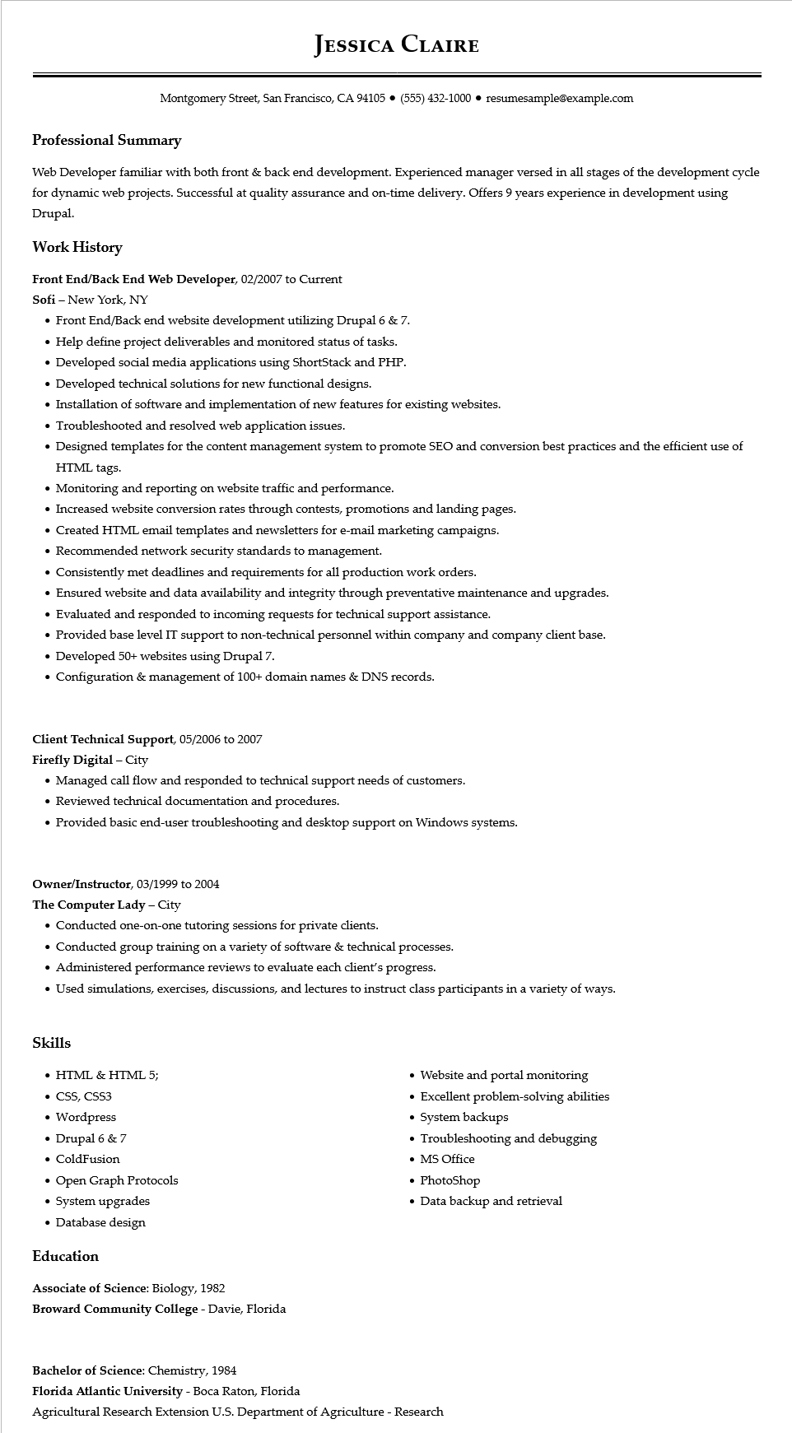
JESSICA CLAIRE
Montgomery Street, San Francisco, CA 94105 ⚫ (555) 432-1000⚫ resumesample@example.com
Professional Summary
Web Developer familiar with both front & back end development. Experienced manager versed in all stages of the development cycle for dynamic web projects. Successful at quality assurance and on-time delivery. Offers 9 years experience in development using Drupal.
Work History
Front End/Back End Web Developer, 02/2007 to Current
Sofi - New York, NY
• Front End/Back end website development utilizing Drupal 6 & 7.
• Help define project deliverables and monitored status of tasks.
• Developed social media applications using ShortStack and PHP.
• Developed technical solutions for new functional designs.
• Installation of software and implementation of new features for existing websites.
• Troubleshooted and resolved web application issues.
• Designed templates for the content management system to promote SEO and conversion best practices and the efficient use of HTML tags.
• Monitoring and reporting on website traffic and performance.
• Increased website conversion rates through contests, promotions and landing pages.
• Created HTML email templates and newsletters for e-mail marketing campaigns.
• Recommended network security standards to management.
• Consistently met deadlines and requirements for all production work orders.
• Ensured website and data availability and integrity through preventative maintenance and upgrades.
• Evaluated and responded to incoming requests for technical support assistance.
• Provided base level IT support to non-technical personnel within company and company client base.
• Developed 50+ websites using Drupal 7.
• Configuration & management of 100+ domain names & DNS records.
Client Technical Support, 05/2006 to 2007
Firefly Digital - City
• Managed call flow and responded to technical support needs of customers.
• Reviewed technical documentation and procedures.
• Provided basic end-user troubleshooting and desktop support on Windows systems.
Owner/Instructor, 03/1999 to 2004
The Computer Lady - City
• Conducted one-on-one tutoring sessions for private clients.
• Conducted group training on a variety of software & technical processes.
• Administered performance reviews to evaluate each client's progress.
• Used simulations, exercises, discussions, and lectures to instruct class participants in a variety of ways.
Skills
• HTML & HTML 5;
• CSS, CSS3
·
Wordpress
• Drupal 6 & 7
• ColdFusion
• Open Graph Protocols
• System upgrades
• Database design
Education
Associate of Science: Biology, 1982
Broward Community College - Davie, Florida
• Website and portal monitoring
• Excellent problem-solving abilities
•
System backups
•
Troubleshooting and debugging
• MS Office
• PhotoShop
• Data backup and retrieval
Bachelor of Science: Chemistry, 1984
Florida Atlantic University - Boca Raton, Florida
Agricultural Research Extension U.S. Department of Agriculture - Research

